In this example we show how to create a new screen for PO creation.

Screen exit: MM06E005 (Customer fields in purchasing document):

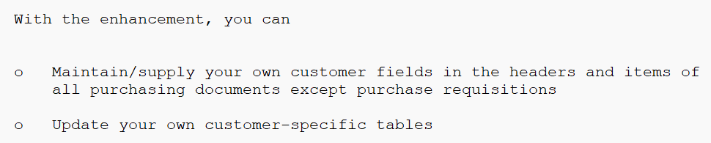

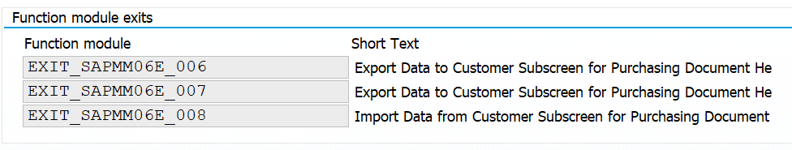

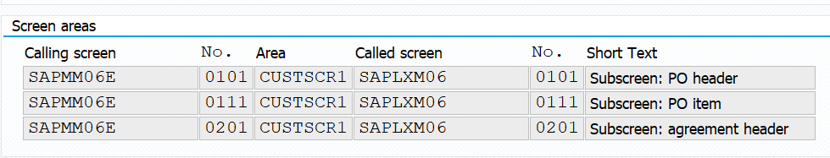

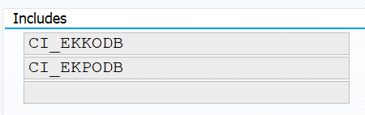

1. Define Include tables

The fields define here will be added into a include area at table EKKO.

We change the structure of CI_EKKODB and it automatically add the fields into the EKKO include.

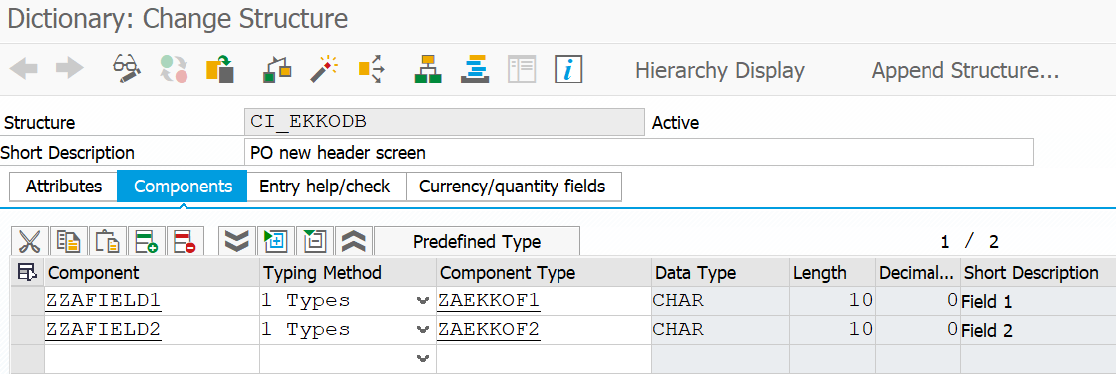

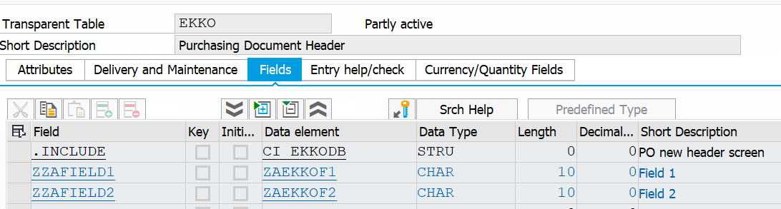

1. Implement the screen-exit

Make sure that the screen type is Subscren

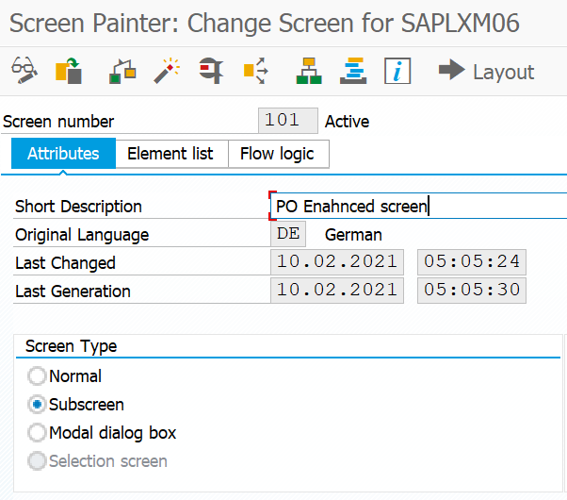

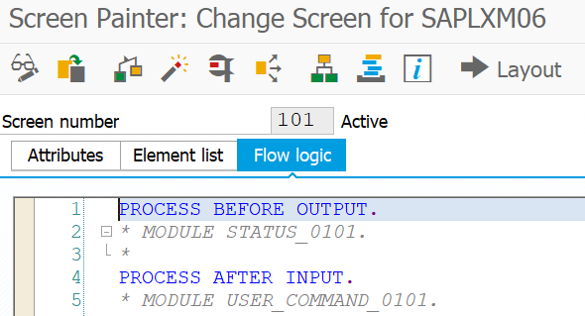

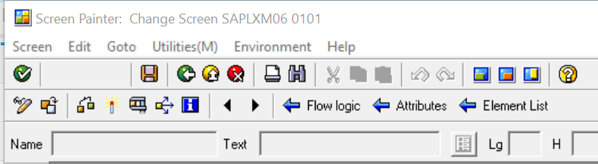

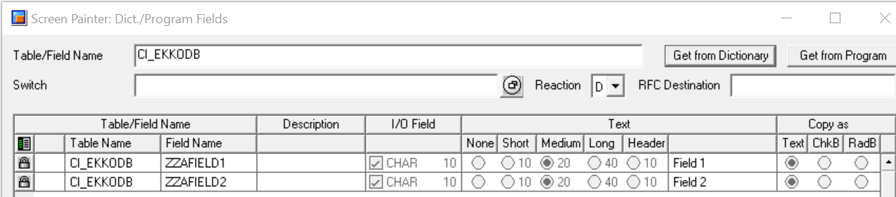

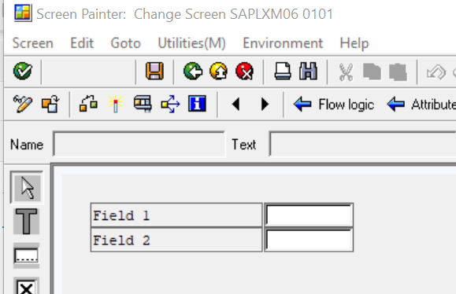

Define screen group as ‘ZA1’ for both fields:

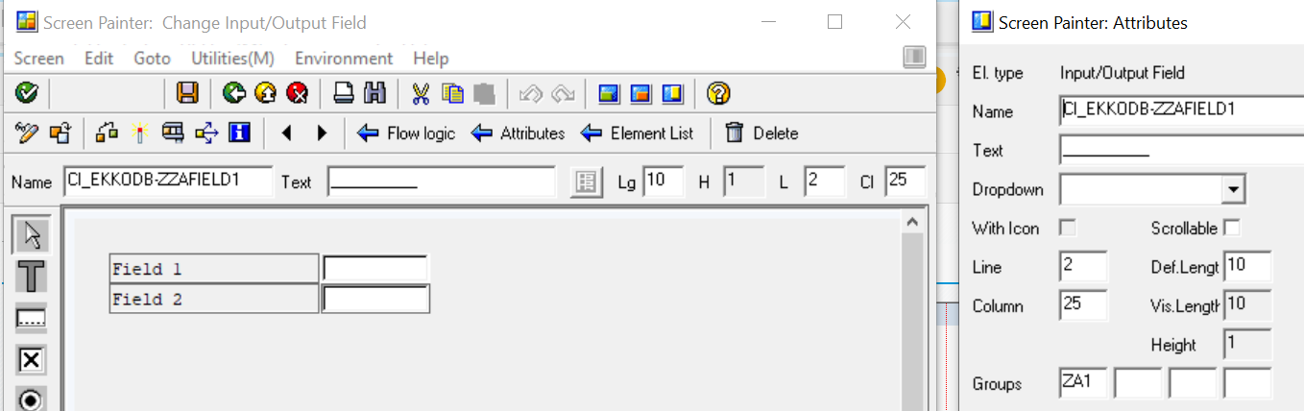

Define a PAI Module:

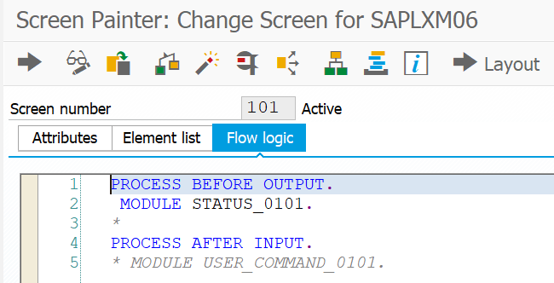

Below code is to make sure that the fields will be greyed-out when in display mode.

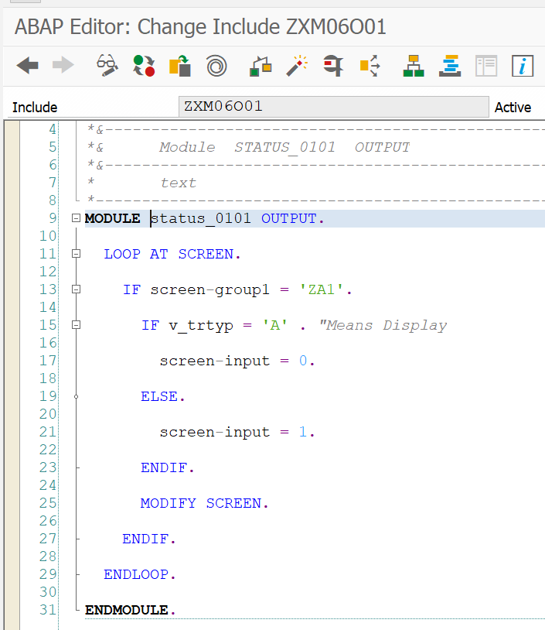

1. Define CI_EKKODB as Global Data in the function-exit group XM06.

Export data from the screen-exit to the standard program.

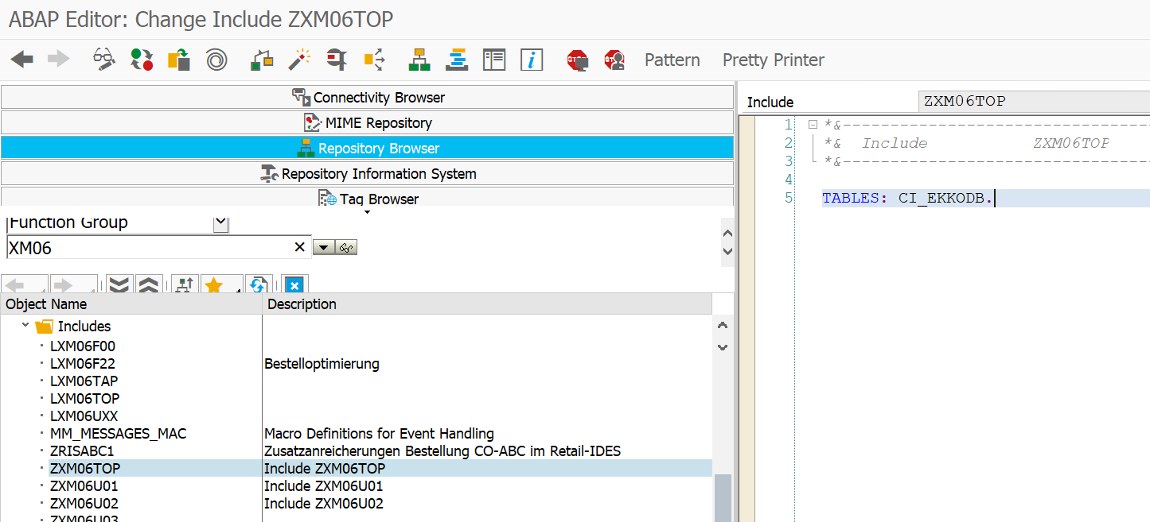

1. Export data from the standard program to the screen-exit.

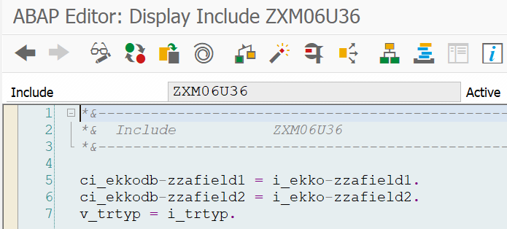

1. Testing.

The new screen is location in the tab Customer Data:

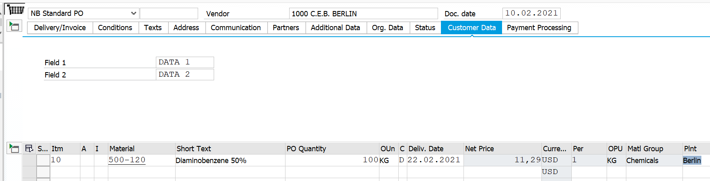



Data was saved correctly.